FULLY AUTOMATIC PACE RATE COMPRESSION TESTING MACHINE CAPACITY: 1000kn(100ton)

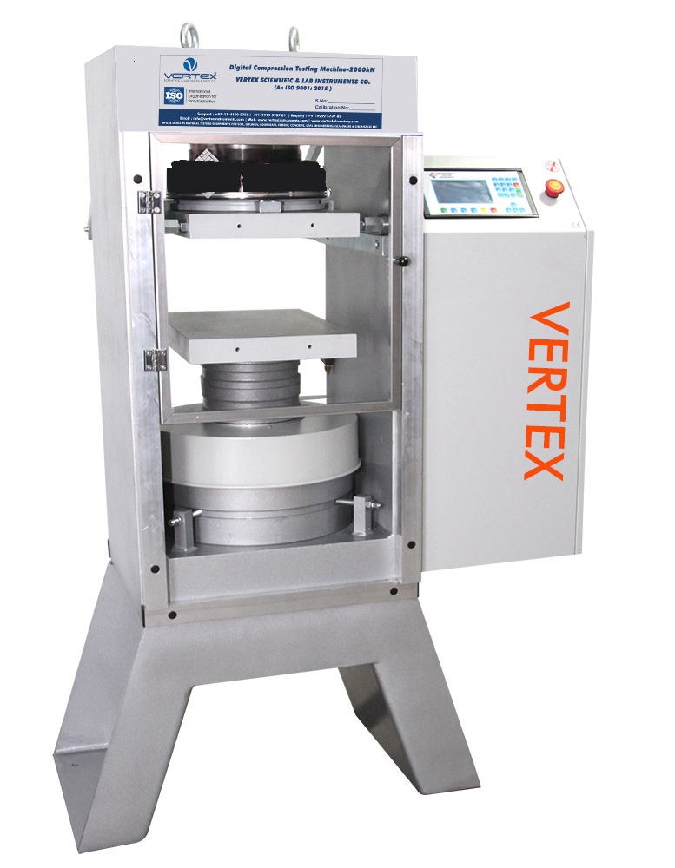

Standard: ASTM C39, AASHTO T22, ISO EN 7500, EN 12390-4, BS 1881 and ASTM C39 IS 14858:2000 | IS: 516 | BS1881

Product Description

Vertex Fully Automatic Compression Testing Machine is a fully automated version of the compression testing machine. The Machine is a available 1000kN Capacity. It has provision for automatically Turing the pump on and off, controlling the set pace rate and switching the machine off under predetermined conditions. The control releases the pressure at the end of every run and reinitializes the machine at the beginning of every test. The pace rate is maintained by means if full three term PID feedback control using high torques steeper motors and driver sets, Data acquisition, storage, management and analysis are all fully automated. VERTEX make Fully Automatic Pace Rate Controlled Compression Testing Machine with all distance platens for 150 mm cube/100 mm cube 150 x 300 mm cylinders, software. The automatic range of 1000 kN capacity compression testing machines has been designed to meet the need for reliable and consistent testing of concrete samples. all VERTEX machines feature the complete automatic test cycle with a closed loop digital readout. Once the specimen parameters have been introduced, it is sufficient to press the start button to complete the test. VERTEX compression machines consist of their main parts: Frame, power pack and data acquisition control system. Each part has been designed to manufacture machines with a high degree of mechanical stability and complies to EN 12390-4, BS 1881 and ASTM C39 (with suitable platen set).

Pumping Unit:

This as 0.5hp, 1ph 220V 230Volt AC Motor driven two-speed hydraulic pump and bonded strain gauge-based pressure transducer.

Standards:
- Automatic test cycle with standard rapid approach
- Pace Rate control between 1 kN to 25 kN
- Graphical - LCD data acquisition and control system
- Menu driven software for easy operation
- Load vs time plot and instantaneous load rate displayed
- Accurate load rate control within ±5 from 1 kN/sec to 20 kN /sec
- Class 1 starting from % 10 of the full range
- Ready stress calculation for the standards of EN 12390-3, EN 12390-5, EN 12390-6, En 1338, EN 1340, EN 196
- SI, Metric, Imperial units
- Piston Stroke: 100
- RS 232 output for printer or PC
- Free of charge PC software for test control and advanced report printout
- Supplied with factory calibration certificate for load measurement
- Fully Auto Controlled- Operable with EDI Through
  - Laptop
  - Desktop P.C
  - Standalone EDI

Frame:
- The load frame is a welded steel fabrication carrying the ball-seated upper platen.
- Positively located on the loading ram which is protected from debris by a cover, the lower platen is marked for the centering of cube and cylinder specimens.
- The dimensions of the frame allow the testing of concrete cylinders up to 320 mm long x 160 mm diameter, 100, 150 mm cubes.
- All machines are supplied complete with 30 mm, 50mm and 90 mm distance pieces.
- To test samples shorter than 150 mm extra distance pieces should be ordered. All machines are supplied with flexi glass front and rear removable safety doors.
- All frames have a single acting upstroking ram with over travel protection to stop the motor when the maximum platen travel be reached.

The Main Characteristics Are:
- High stability welded assembly
- 50 mm piston stroke with safety limit switch
- Platen hardness of min 55 HRC
- Distance pieces and safety door included
- Ball seating assembly and frame tested for stability

Data Acquisition and Control System:
- LCD graphics data acquisition and controls system is designed to control the machine and processing of data from load cells or pressure transducers installed on the compression machine frame.
- The easy-to-read lcd graphic display and touch-button data pad keys make the unit quick and straight forward to operate.
- All interactions with the measuring system are via the front control panel by using simple menu-driven procedures.
- The bc100 is contained in light alloy housing and its design satisfies the ergonomic requirements for various use.
- The bc100 digital graphic display allows real time load vs time graph.
- At the end of the test cycle, the results can be stored in the large memory or downloaded to a PC in VERTEX software format.

Technical Specification

Capacity | 1000 kN
Frame Type | Welded Steel
Lower Bearing Block,  Dimensions (D) | (Block) 310x410x90mm (12.2”x16.1”x3.5”)  (Circular) Ø165 mm (6.5")
Upper Bearing Block,  (With Spherically Seating Assembly) Dimensions (C) | (Block) 310x410x90mm (12.2”x16.1”x3.5”)  (Circular) Ø165 mm (6.5")
Surface Hardness of Bearing Platens | (Block) 60 HRC  (Circular) 55 HRC
Flatness Tolerance | (Block) 0,025 mm/150 mm (0,001”/6”)  (Circular) 0,02 mm/150 mm (0,001”/6”)
Maximum Vertical Clearance  Between Bearing Blocks (E) | (Block) 250 mm (9,84”)  (Circular) 380 mm (15”)
Piston Diameter | 250 mm (9,84”)
Piston Stroke | 50 mm (1,97”)
Horizontal Clearance (B) | 360 mm (14,17”)
Dimensions (wxlxh) (Axd*xF) | 790x453x1144 mm  (31,1x17,83”x45,04”)
Weight | 753 kg (2190 lb)

